Министерство образования Республики Беларусь

Учреждение образования

БЕЛОРУССКИЙ ГОСУДАРСТВЕННЫЙ УНИВЕРСИТЕТ

ИНФОРМАТИКИ И РАДИОЭЛЕКТРОНИКИ

Факультет компьютерных систем и сетей

Кафедра электронных вычислительных машин

ОТЧЕТ

по лабораторной работе №3

на тему

Реализация SQL-запросов для создания схемы базы данных

Больнциа

Студент: Д.И. Ковальчук

Преподаватель: Д.В. Куприянова

МИНСК 2024

1. **Цель работы**

В лабораторной работе выполняется реализация схемы базы данных по ранее построенной реляционной схеме данных (см. лабораторную работу № 2). Требуется сформировать SQL-запросы для создания таблиц базы данных и выполнить их в СУБД. Требуется заполнить таблицы данными с помощью оператора INSERT.

1. **Порядок выполнения работы**

1) Создать в СУБД новую схему данных для хранения пользовательских объектов (см. часть 2).

2) В этой новой схеме данных с помощью скрипта с запросами на языке DDL SQL реализовать таблицы, соответствующие реляционным отношениям схемы данных полученной в лабораторной работе No2, с помощью одного (желательно) оператора CREATE TABLE для каждой таблицы в следующем порядке:

- реализовать простую структуру таблиц, включающую только набор столбцов с добавлением описаний первичного ключа;

- дополнить описание таблицы реализацией ограничений для описания внешних ключей; для внешних ключей установить свойства контроля целостности данных (каскадное удаление и обновление), если это возможно в целевой СУБД;

- дополнить описание таблицы реализацией ограничений для описания бизнес-правил;

- дополнить описание таблицы реализацией комментариев для значимых элементов таблицы.

3) Заполнить с помощью SQL-скрипта с использованием оператора INSERT таблицы строками данных для проверки правильного выбора первичных ключей и работоспособности ссылок между таблицами:

- строками данных сначала заполнять мастер-таблицы (или таблицы, которые НЕ ссылаются на другие таблицы);

- в каждую таблицу добавить 30 строк осмысленных данных;

- если не удается добавить данные в таблицу по причине нарушения уникальности первичного ключа, то следует перепроверить описание этого первичного ключа и его смысл для реального мира;

‑ если не удается добавить данные в таблицу по причине нарушения ссылочной целостности, то следует убедиться, что целевые данные существуют, иначе перепроверить описание внешнего ключа.

4) Рассмотреть простые действия по изменению структуры таблицы (переименование столбца таблицы, добавление и удаление ограничений на столбец таблицы или всю таблицу) и реализовать их с помощью оператора ALTER TABLE.

5) Создать временную таблицу с помощью оператора CREATE TABLE и удалить ее с помощью оператора DROP TABLE.

6) Экспортировать результаты работы в SQL-скрипт (см. часть 2), сравнить полученный скрипт со скриптами, созданными на этапах 2 и 3.

1. **Выполнение работы**

Реляционная схема данных, построенная в лабораторной работе №2 приведена на рисунке 3.1.

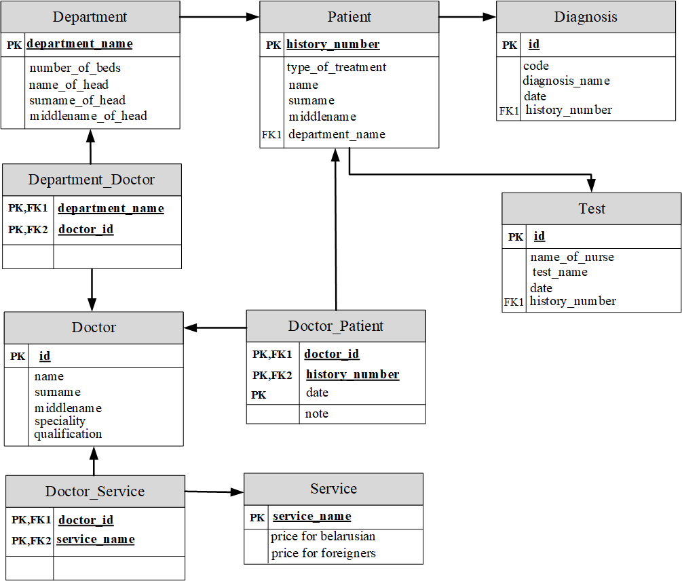

Рисунок 3.1 – Реляционная схема данных

База данных создаётся при помощи запроса CREATE DATABASE hospital.

Для создания таблиц использовался следующий запрос:

CREATE TABLE department (

department_name text PRIMARY KEY,

number_of_beds integer,

surname_of_head text,

first_name_of_head text,

middle_name_of_head text

);

CREATE TABLE patient (

history_number integer PRIMARY KEY,

type_of_treatment text,

surname text,

first_name text,

middle_name text,

department_name text references department(department_name)

);

CREATE TABLE diagnosis(

diagnosis_id integer PRIMARY KEY,

code text,

diagnosis_name text,

date_ date,

history_number integer references parient(history_number)

);

CREATE TABLE doctor(

doctor_id integer PRIMARY KEY

surname text,

first_name text,

middle_name text,

speciality text,

qualification text

);

CREATE TABLE service(

service_name text PRIMARY KEY,

price_for_belarusian integer,

price_for_foreigners integer

);

CREATE TABLE test(

test_id integer PRIMARY KEY,

name_of_nurse text,

test_name text,

date_ date,

history_number integer references patient(history_number)

);

CREATE TABLE department_doctor(

department_name text references department(department_name),

doctor_id integer references doctor(doctor_id),

PRIMARY KEY(department_name, doctor_id)

);

CREATE TABLE doctor_service(

service_name text references service(service_name),

doctor_id integer references doctor(doctor_id),

PRIMARY KEY(service_name, doctor_id)

);

CREATE TABLE doctor_patient(

history_number integer references patient(history_number),

doctor_id integer references doctor(doctor_id),

date_ date,

note text,

PRIMARY KEY(history_number, doctor_id, date_)

);

Для добавления ограничений используются конструкция ADD CONSTRAINT в связке с оператором ALTER. Пример добавления условия, что ни одно из полей не нулевое, для таблицы service представлен ниже:

ALTER TABLE IF EXISTS service

ADD CONSTRAINT not_null CHECK(

service_name IS NOT NULL AND

price_for_belarusian IS NOT NULL AND

price_for_foreigners IS NOT NULL

);

Пример добавления комментария к таблице department_doctor:

COMMENT ON TABLE department_doctor

IS 'Intermediate table between tables department and doctor';

Пример установки свойства контроля целостности данных (каскадное удаление и обновление) в таблице test:

ALTER TABLE test

ADD CONSTRAINT del_upd

FOREIGN KEY (history_number)

REFERENCES patient (history_number)

ON DELETE CASCADE

ON UPDATE CASCADE

Заполнение таблиц test, doctor, diagnosis, patient, department при помощи оператора INSERT INTO:

INSERT INTO department (department_name, number_of_beds, surname_of_head, first_name_of_head, middle_name_of_head)

VALUES

('Cardiology', 50, 'Smith', 'John', 'Alexander'),

('Pediatrics', 30, 'Johnson', 'Emily', 'Rose'),

('Orthopedics', 25, 'Williams', 'James', 'Matthew'),

('Ophthalmology', 20, 'Brown', 'Olivia', 'Sophia'),

('Dermatology', 15, 'Jones', 'Emma', 'Grace'),

('Neurology', 40, 'Taylor', 'Daniel', 'Joseph'),

('Gastroenterology', 35, 'Wilson', 'Sophia', 'Elizabeth'),

('Urology', 15, 'Miller', 'Michael', 'David'),

('Otolaryngology', 20, 'Anderson', 'Ava', 'Grace'),

('Psychiatry', 30, 'Thomas', 'Ethan', 'Benjamin'),

('Radiology', 25, 'Martinez', 'Isabella', 'Lily'),

('Endocrinology', 20, 'Harris', 'Mia', 'Charlotte'),

('Rheumatology', 15, 'Clark', 'Abigail', 'Elizabeth'),

('Hematology', 30, 'Lewis', 'Elijah', 'Alexander'),

('Nephrology', 20, 'Lee', 'Amelia', 'Madison'),

('Gynecology', 25, 'Walker', 'Liam', 'Christopher'),

('Pulmonology', 30, 'Green', 'Harper', 'Grace'),

('Oncology', 25, 'Gonzalez', 'Evelyn', 'Victoria'),

('Neonatology', 20, 'Morris', 'Charlotte', 'Rose'),

('Allergy and Immunology', 15, 'Allen', 'Henry', 'William'),

('Infectious Diseases', 20, 'Young', 'Scarlett', 'Isabella'),

('Dentistry', 25, 'King', 'Zoe', 'Elizabeth'),

('Physical Therapy', 30, 'Wright', 'Carter', 'James'),

('Occupational Therapy', 25, 'Hall', 'Grace', 'Ann'),

('Speech-language Pathology', 20, 'Turner', 'Samuel', 'Jacob'),

('Emergency Medicine', 15, 'Baker', 'Lily', 'Grace'),

('General Surgery', 30, 'Hill', 'Lucas', 'Matthew'),

('Plastic Surgery', 25, 'Ward', 'Nora', 'Emily'),

('Anesthesiology', 20, 'Cook', 'Levi', 'Benjamin'),

('Pathology', 15, 'Price', 'Ella', 'Sophia');

INSERT INTO patient (history_number, type_of_treatment, surname, first_name, middle_name, department_name)

VALUES

(1001, 'Consultation', 'Smith', 'John', 'Alexander', 'Cardiology'),

(1002, 'Surgery', 'Johnson', 'Emily', 'Rose', 'Orthopedics'),

(1003, 'Check-up', 'Williams', 'James', 'Matthew', 'Pediatrics'),

(1004, 'Treatment', 'Brown', 'Olivia', 'Sophia', 'Dermatology'),

(1005, 'Consultation', 'Jones', 'Emma', 'Grace', 'Gastroenterology'),

(1006, 'Surgery', 'Taylor', 'Daniel', 'Joseph', 'Neurology'),

(1007, 'Check-up', 'Wilson', 'Sophia', 'Elizabeth', 'Gynecology'),

(1008, 'Treatment', 'Miller', 'Michael', 'David', 'Urology'),

(1009, 'Consultation', 'Anderson', 'Ava', 'Grace', 'Otolaryngology'),

(1010, 'Surgery', 'Thomas', 'Ethan', 'Benjamin', 'Radiology'),

(1011, 'Check-up', 'Martinez', 'Isabella', 'Lily', 'Endocrinology'),

(1012, 'Treatment', 'Harris', 'Mia', 'Charlotte', 'Rheumatology'),

(1013, 'Consultation', 'Clark', 'Abigail', 'Elizabeth', 'Hematology'),

(1014, 'Surgery', 'Lewis', 'Elijah', 'Alexander', 'Nephrology'),

(1015, 'Check-up', 'Lee', 'Amelia', 'Madison', 'Oncology'),

(1016, 'Treatment', 'Walker', 'Liam', 'Christopher', 'Neonatology'),

(1017, 'Consultation', 'Green', 'Harper', 'Grace', 'Allergy and Immunology'),

(1018, 'Surgery', 'Gonzalez', 'Evelyn', 'Victoria', 'Infectious Diseases'),

(1019, 'Check-up', 'Morris', 'Charlotte', 'Rose', 'Dentistry'),

(1020, 'Treatment', 'Allen', 'Henry', 'William', 'Physical Therapy'),

(1021, 'Consultation', 'Smith', 'Sophia', 'Grace', 'Cardiology'),

(1022, 'Surgery', 'Johnson', 'Liam', 'James', 'Orthopedics'),

(1023, 'Check-up', 'Williams', 'Ava', 'Elizabeth', 'Pediatrics'),

(1024, 'Treatment', 'Brown', 'Oliver', 'Matthew', 'Dermatology'),

(1025, 'Consultation', 'Jones', 'Mia', 'Grace', 'Gastroenterology'),

(1026, 'Surgery', 'Taylor', 'Noah', 'Joseph', 'Neurology'),

(1027, 'Check-up', 'Wilson', 'Olivia', 'Rose', 'Gynecology'),

(1028, 'Treatment', 'Miller', 'James', 'David', 'Urology'),

(1029, 'Consultation', 'Anderson', 'Emma', 'Grace', 'Otolaryngology'),

(1030, 'Surgery', 'Thomas', 'Liam', 'Benjamin', 'Radiology');

INSERT INTO diagnosis (diagnosis_id, code, diagnosis_name, date_, history_number)

VALUES

(1, 'A001', 'Common Cold', '2023-10-05', 1001),

(2, 'B352', 'Pneumonia', '2023-08-15', 1002),

(3, 'C526', 'Gastroenteritis', '2023-09-22', 1003),

(4, 'D723', 'Skin Infection', '2023-11-10', 1004),

(5, 'E905', 'Allergic Rhinitis', '2023-07-29', 1005),

(6, 'F201', 'Migraine', '2023-12-02', 1006),

(7, 'G431', 'Urinary Tract Infection', '2023-10-18', 1007),

(8, 'H821', 'Otitis Media', '2023-06-14', 1008),

(9, 'I509', 'Hypertension', '2023-09-01', 1009),

(10, 'J303', 'Bronchitis', '2023-11-26', 1010),

(11, 'A001', 'Common Cold', '2023-08-28', 1001),

(12, 'B352', 'Pneumonia', '2023-10-12', 1012),

(13, 'C526', 'Gastroenteritis', '2023-07-17', 1003),

(14, 'D723', 'Skin Infection', '2023-09-05', 1014),

(15, 'E905', 'Allergic Rhinitis', '2023-11-21', 1005),

(16, 'F201', 'Migraine', '2023-08-08', 1016),

(17, 'G431', 'Urinary Tract Infection', '2023-10-25', 1007),

(18, 'H821', 'Otitis Media', '2023-12-19', 1018),

(19, 'I509', 'Hypertension', '2023-09-15', 1009),

(20, 'J303', 'Bronchitis', '2023-06-30', 1020),

(21, 'A001', 'Common Cold', '2023-11-15', 1021),

(22, 'B352', 'Pneumonia', '2023-07-04', 1022),

(23, 'C526', 'Gastroenteritis', '2023-09-09', 1023),

(24, 'D723', 'Skin Infection', '2023-12-25', 1024),

(25, 'E905', 'Allergic Rhinitis', '2023-10-02', 1025),

(26, 'F201', 'Migraine', '2023-08-20', 1026),

(27, 'G431', 'Urinary Tract Infection', '2023-11-06', 1027),

(28, 'H821', 'Otitis Media', '2023-07-23', 1028),

(29, 'I509', 'Hypertension', '2023-09-29', 1029),

(30, 'J303', 'Bronchitis', '2023-06-07', 1030);

INSERT INTO doctor (doctor_id, surname, first_name, middle_name, speciality, qualification)

VALUES

(1, 'Smith', 'John', 'Michael', 'Cardiology', 'First'),

(2, 'Johnson', 'Robert', 'David', 'Orthopedics', 'Second'),

(3, 'Williams', 'James', 'Thomas', 'Dermatology', 'Higher'),

(4, 'Jones', 'William', 'Christopher', 'Pediatrics', 'First'),

(5, 'Brown', 'David', 'Joseph', 'Ophthalmology', 'Second'),

(6, 'Davis', 'Charles', 'Daniel', 'Gastroenterology', 'Higher'),

(7, 'Miller', 'Daniel', 'Matthew', 'Neurology', 'First'),

(8, 'Wilson', 'Joseph', 'Anthony', 'Otolaryngology', 'Second'),

(9, 'Moore', 'Thomas', 'Andrew', 'Urology', 'Higher'),

(10, 'Taylor', 'Mark', 'Jason', 'Psychiatry', 'First'),

(11, 'Anderson', 'Michael', 'Timothy', 'Cardiology', 'Second'),

(12, 'Thomas', 'David', 'Richard', 'Orthopedics', 'Higher'),

(13, 'Jackson', 'Charles', 'Edward', 'Dermatology', 'First'),

(14, 'White', 'Robert', 'William', 'Pediatrics', 'Second'),

(15, 'Harris', 'Matthew', 'George', 'Ophthalmology', 'Higher'),

(16, 'Martin', 'Brian', 'Scott', 'Gastroenterology', 'First'),

(17, 'Thompson', 'Jason', 'Alexander', 'Neurology', 'Second'),

(18, 'Garcia', 'Kevin', 'Joseph', 'Otolaryngology', 'Higher'),

(19, 'Martinez', 'Edward', 'Ryan', 'Urology', 'First'),

(20, 'Robinson', 'William', 'Benjamin', 'Psychiatry', 'Second'),

(21, 'Clark', 'Joshua', 'Samuel', 'Cardiology', 'Higher'),

(22, 'Rodriguez', 'Daniel', 'Stephen', 'Orthopedics', 'First'),

(23, 'Lewis', 'Andrew', 'Peter', 'Dermatology', 'Second'),

(24, 'Lee', 'Christopher', 'Frank', 'Pediatrics', 'Higher'),

(25, 'Walker', 'Matthew', 'Raymond', 'Ophthalmology', 'First'),

(26, 'Hall', 'Joseph', 'Patrick', 'Gastroenterology', 'Second'),

(27, 'Allen', 'David', 'Jack', 'Neurology', 'Higher'),

(28, 'Young', 'Daniel', 'Henry', 'Otolaryngology', 'First'),

(29, 'Hernandez', 'Anthony', 'Ronald', 'Urology', 'Second'),

(30, 'King', 'Thomas', 'Edward', 'Psychiatry', 'Higher');

INSERT INTO test (test_id, name_of_nurse, test_name, date_, history_number)

VALUES

(1, 'Johnson', 'Blood Test', '2024-01-01', 1001),

(2, 'Smith', 'X-ray', '2024-01-02', 1002),

(3, 'Williams', 'Ultrasound', '2024-01-03', 1003),

(4, 'Brown', 'MRI', '2024-01-04', 1004),

(5, 'Jones', 'CT Scan', '2024-01-05', 1001),

(6, 'Davis', 'Blood Test', '2024-01-06', 1005),

(7, 'Miller', 'X-ray', '2024-01-07', 1017),

(8, 'Wilson', 'Ultrasound', '2024-01-08', 1017),

(9, 'Moore', 'MRI', '2024-01-09', 1018),

(10, 'Taylor', 'CT Scan', '2024-01-10', 1020),

(11, 'Johnson', 'Blood Test', '2024-01-11', 1008),

(12, 'Thomas', 'X-ray', '2024-01-12', 1009),

(13, 'Johnson', 'Ultrasound', '2024-01-13', 1002),

(14, 'White', 'MRI', '2024-01-14', 1010),

(15, 'Johnson', 'CT Scan', '2024-01-15', 1010),

(16, 'Martin', 'Blood Test', '2024-01-16', 1011),

(17, 'Johnson', 'X-ray', '2024-01-17', 1012),

(18, 'Garcia', 'Ultrasound', '2024-01-18', 1013),

(19, 'Johnson', 'MRI', '2024-01-19', 1014),

(20, 'Robinson', 'CT Scan', '2024-01-20', 1013),

(21, 'Clark', 'Blood Test', '2024-01-21', 1015),

(22, 'Rodriguez', 'X-ray', '2024-01-22', 1018),

(23, 'Lewis', 'Ultrasound', '2024-01-23', 1021),

(24, 'Lee', 'MRI', '2024-01-24', 1022),

(25, 'Walker', 'CT Scan', '2024-01-25', 1023),

(26, 'Hall', 'Blood Test', '2024-01-26', 1024),

(27, 'Johnson', 'X-ray', '2024-01-27', 1025),

(28, 'Young', 'Ultrasound', '2024-01-28', 1025),

(29, 'Hernandez', 'MRI', '2024-01-29', 1027),

(30, 'King', 'CT Scan', '2024-01-30', 1026);

Таблицы service, department_doctor, doctor_service и doctor_patient были заполнены вручную.

Для заполнения вручную необходимо выбрать нужную таблицу, далее выбрать View/Edit Data, потом выбрать All Rows.

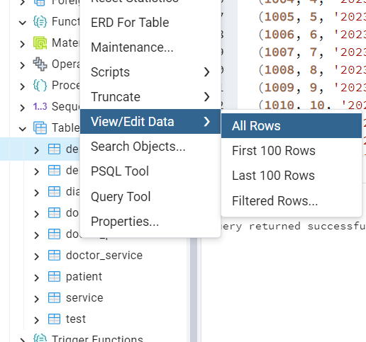

Рисунок 3.2 – Открытие окна для ручного ввода значений.

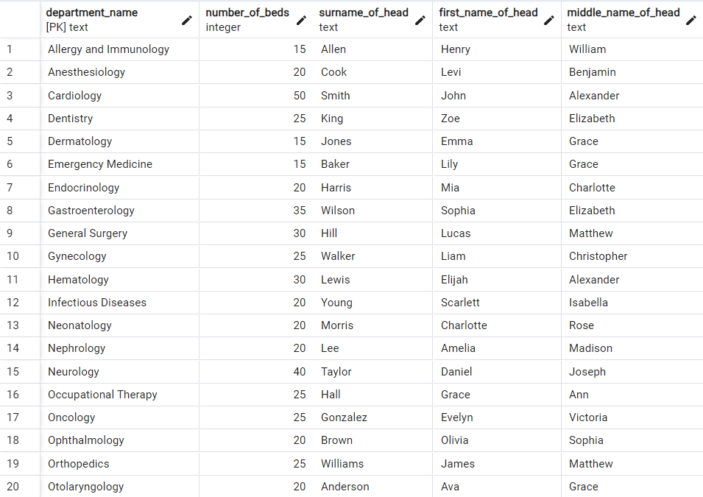

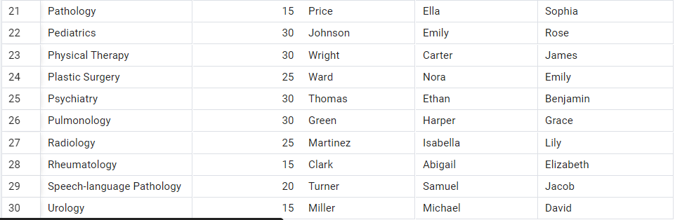

Рисунок 3.3 – Заполненная таблица department.

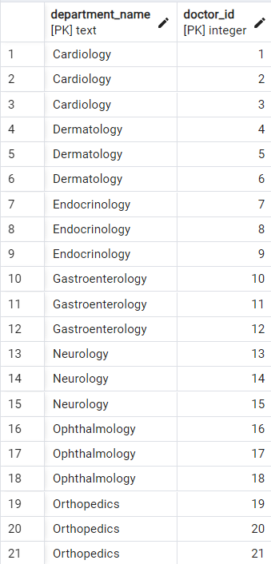

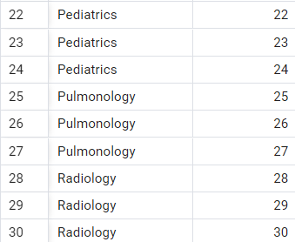

Рисунок 3.4 – Заполненная таблица department-doctor.

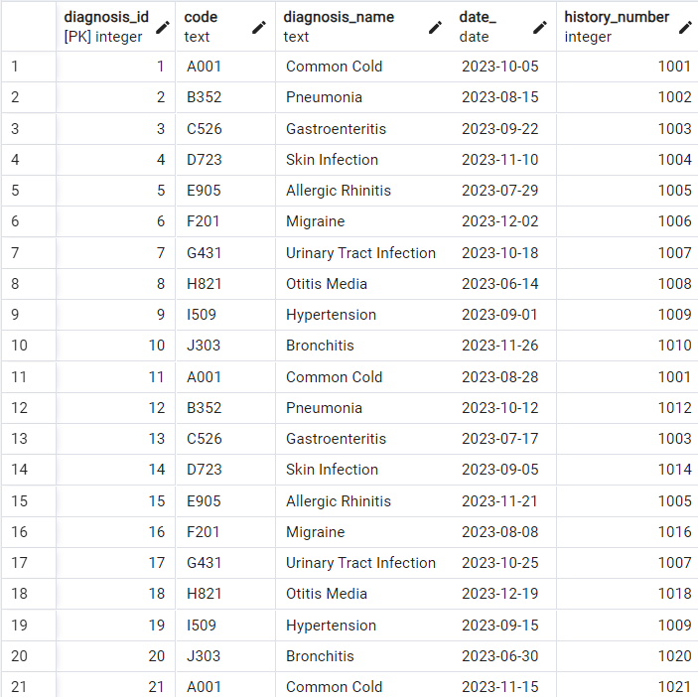

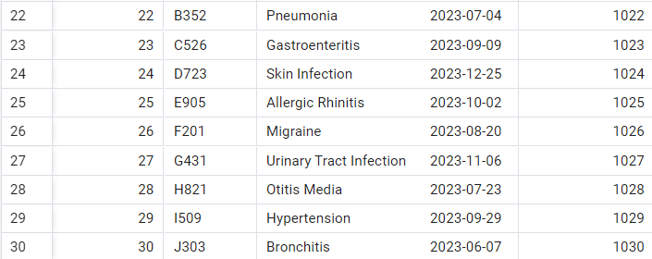

Рисунок 3.5 – Заполненная таблица diagnosis.

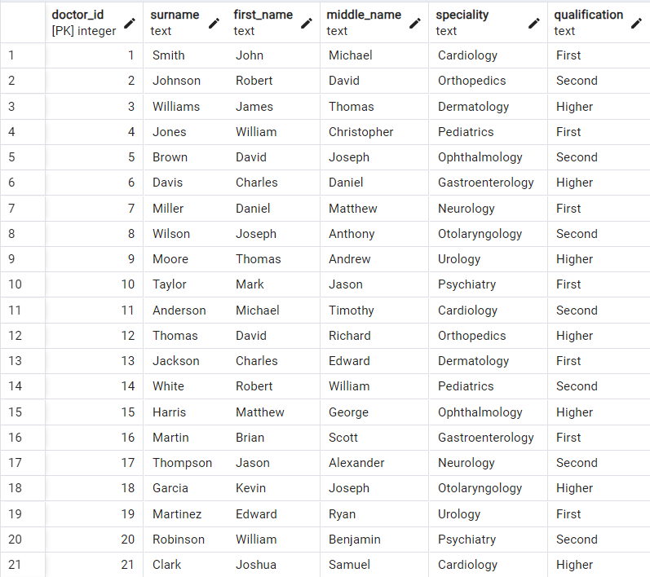

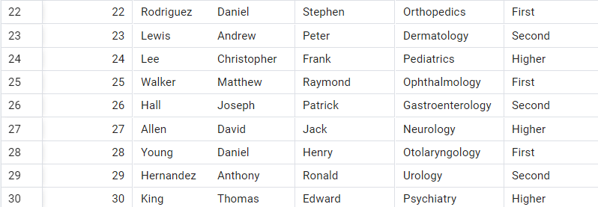

Рисунок 3.6 – Заполненная таблица doctor.

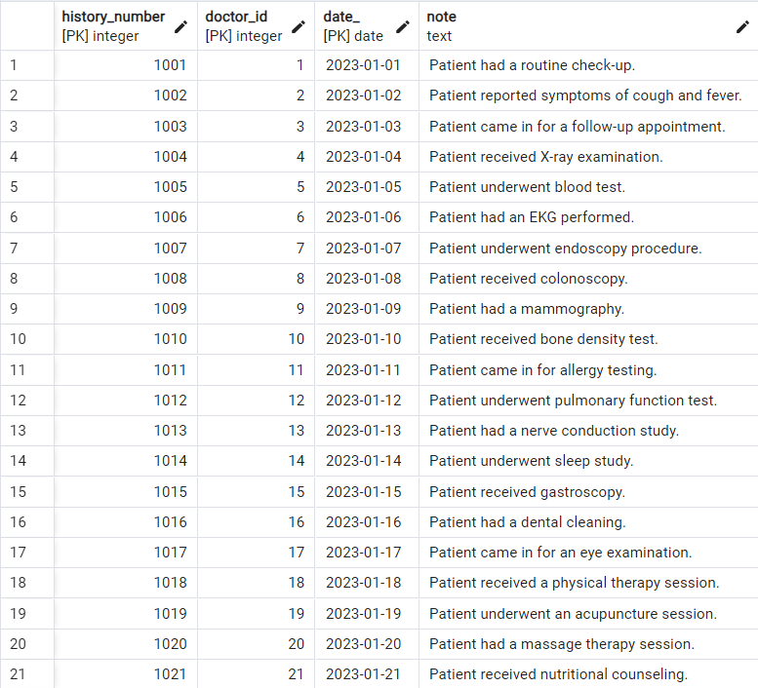

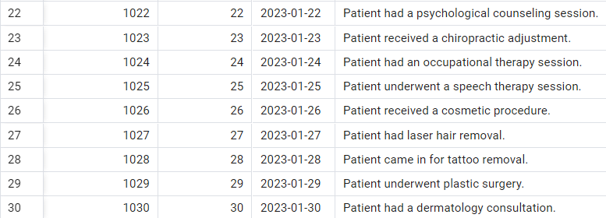

Рисунок 3.7 – Заполненная таблица doctor-patient.

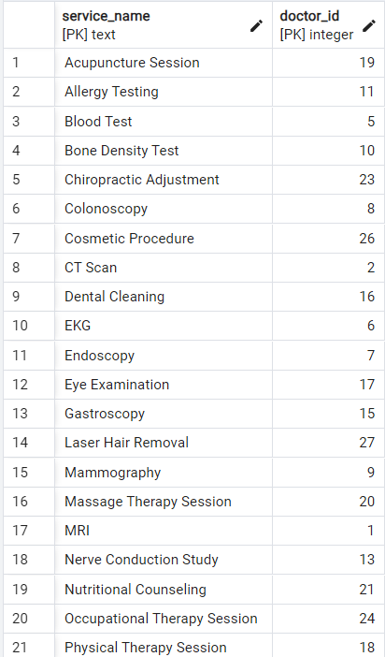

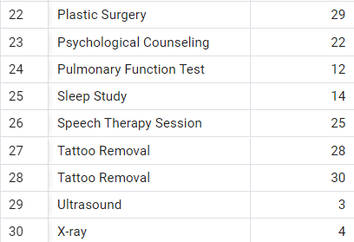

Рисунок 3.8 – Заполненная таблица doctor-service.

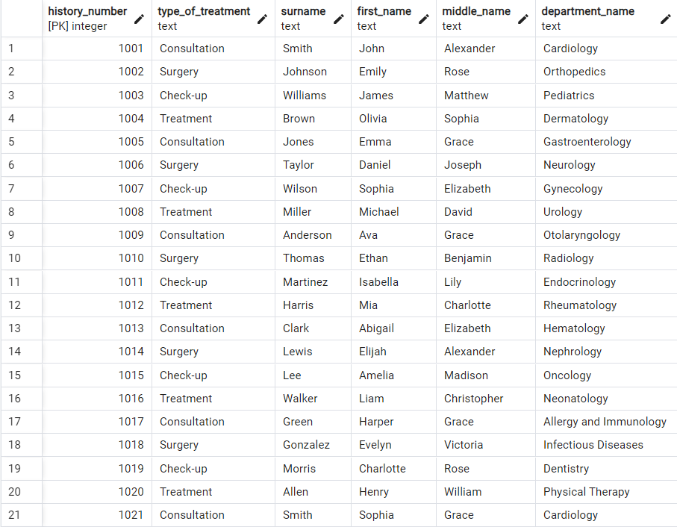

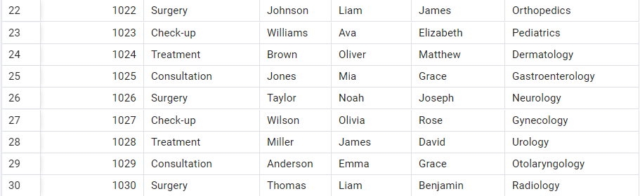

Рисунок 3.9 – Заполненная таблица pacient.

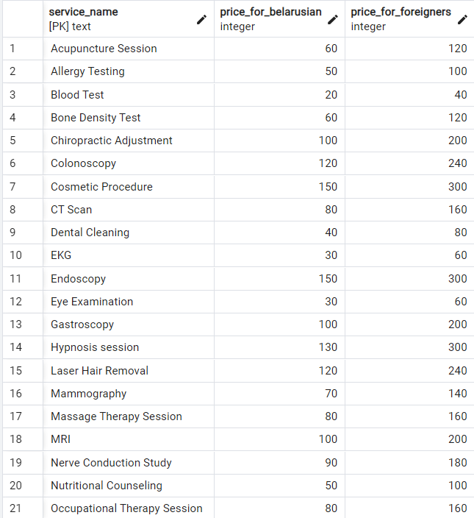

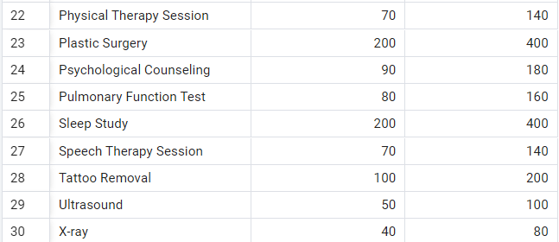

Рисунок 3.10 – Заполненная таблица service.

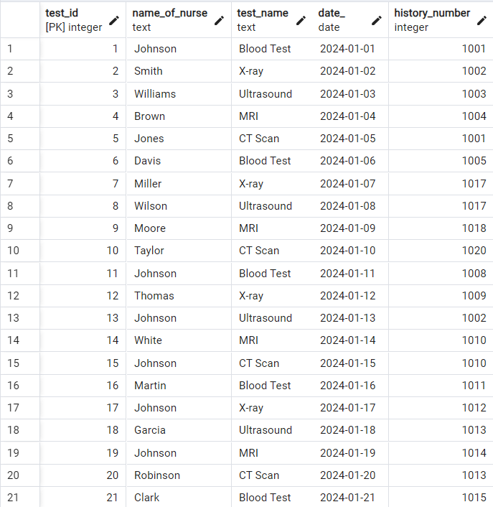

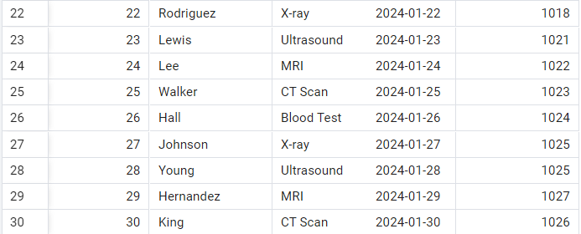

Рисунок 3.11 – Заполненная таблица test.

Также была создана реляционная диаграмма, приведенная на рисунке 3.12.

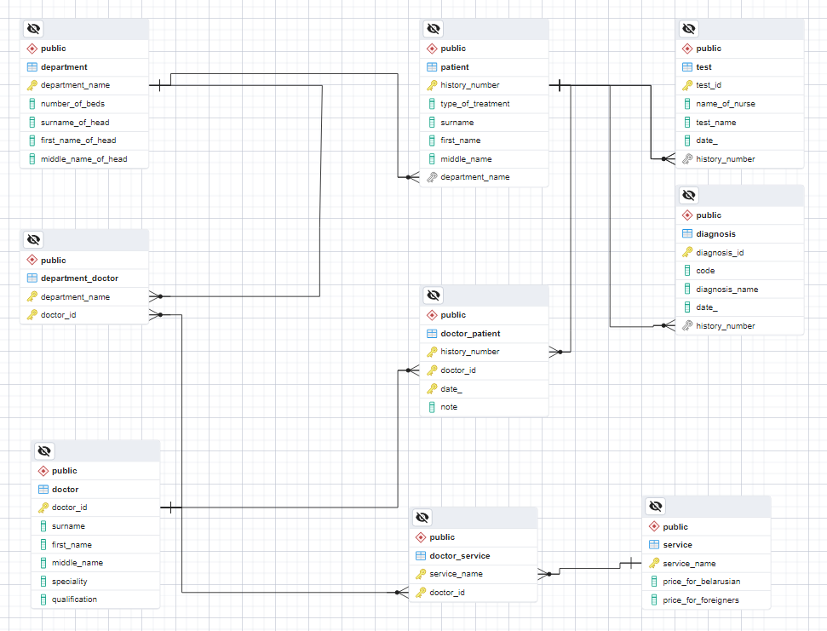

Рисунок 3.12 – Реляционная модель «Больница» в «PgAdmin 4»

После сравнения полученной диаграммы и схемы реляционной модели из отчета по лабораторной работе №2 различий в структуре этих диаграмм не было обнаружено.

Результатом выполнения шага 6 является нижепреведенный SQL-скрипт:

SET statement_timeout = 0;

SET lock_timeout = 0;

SET idle_in_transaction_session_timeout = 0;

SET client_encoding = 'UTF8';

SET standard_conforming_strings = on;

SELECT pg_catalog.set_config('search_path', '', false);

SET check_function_bodies = false;

SET xmloption = content;

SET client_min_messages = warning;

SET row_security = off;

CREATE DATABASE hospital WITH TEMPLATE = template0 ENCODING = 'UTF8' LOCALE_PROVIDER = libc LOCALE = 'en_US.UTF-8';

ALTER DATABASE hospital OWNER TO postgres;

\connect hospital

SET statement_timeout = 0;

SET lock_timeout = 0;

SET idle_in_transaction_session_timeout = 0;

SET client_encoding = 'UTF8';

SET standard_conforming_strings = on;

SELECT pg_catalog.set_config('search_path', '', false);

SET check_function_bodies = false;

SET xmloption = content;

SET client_min_messages = warning;

SET row_security = off;

SET default_tablespace = '';

SET default_table_access_method = heap;

CREATE TABLE public.department (

department_name text NOT NULL,

number_of_beds integer,

surname_of_head text,

first_name_of_head text,

middle_name_of_head text

);

ALTER TABLE public.department OWNER TO postgres;

CREATE TABLE public.department_doctor (

department_name text NOT NULL,

doctor_id integer NOT NULL

);

ALTER TABLE public.department_doctor OWNER TO postgres;

COMMENT ON TABLE public.department_doctor IS 'Intermediate table between tables department and doctor';

CREATE TABLE public.diagnosis (

diagnosis_id integer NOT NULL,

code text,

diagnosis_name text,

date_ date,

history_number integer

);

ALTER TABLE public.diagnosis OWNER TO postgres;

CREATE TABLE public.doctor (

doctor_id integer NOT NULL,

surname text,

first_name text,

middle_name text,

speciality text,

qualification text

);

ALTER TABLE public.doctor OWNER TO postgres;

CREATE TABLE public.doctor_patient (

history_number integer NOT NULL,

doctor_id integer NOT NULL,

date_ date NOT NULL,

note text

);

ALTER TABLE public.doctor_patient OWNER TO postgres;

CREATE TABLE public.doctor_service (

service_name text NOT NULL,

doctor_id integer NOT NULL

);

ALTER TABLE public.doctor_service OWNER TO postgres;

CREATE TABLE public.patient (

history_number integer NOT NULL,

type_of_treatment text,

surname text,

first_name text,

middle_name text,

department_name text

);

ALTER TABLE public.patient OWNER TO postgres;

CREATE TABLE public.service (

service_name text NOT NULL,

price_for_belarusian integer,

price_for_foreigners integer,

CONSTRAINT not_null CHECK (((service_name IS NOT NULL) AND (price_for_belarusian IS NOT NULL) AND (price_for_foreigners IS NOT NULL)))

);

ALTER TABLE public.service OWNER TO postgres;

CREATE TABLE public.test (

test_id integer NOT NULL,

name_of_nurse text,

test_name text,

date_ date,

history_number integer

);

ALTER TABLE public.test OWNER TO postgres;

INSERT INTO public.department VALUES ('Cardiology', 50, 'Smith', 'John', 'Alexander') ON CONFLICT DO NOTHING;

INSERT INTO public.department VALUES ('Pediatrics', 30, 'Johnson', 'Emily', 'Rose') ON CONFLICT DO NOTHING;

INSERT INTO public.department VALUES ('Orthopedics', 25, 'Williams', 'James', 'Matthew') ON CONFLICT DO NOTHING;

INSERT INTO public.department VALUES ('Ophthalmology', 20, 'Brown', 'Olivia', 'Sophia') ON CONFLICT DO NOTHING;

INSERT INTO public.department VALUES ('Dermatology', 15, 'Jones', 'Emma', 'Grace') ON CONFLICT DO NOTHING;

INSERT INTO public.department VALUES ('Neurology', 40, 'Taylor', 'Daniel', 'Joseph') ON CONFLICT DO NOTHING;

INSERT INTO public.department VALUES ('Gastroenterology', 35, 'Wilson', 'Sophia', 'Elizabeth') ON CONFLICT DO NOTHING;

INSERT INTO public.department VALUES ('Urology', 15, 'Miller', 'Michael', 'David') ON CONFLICT DO NOTHING;

INSERT INTO public.department VALUES ('Otolaryngology', 20, 'Anderson', 'Ava', 'Grace') ON CONFLICT DO NOTHING;

INSERT INTO public.department VALUES ('Psychiatry', 30, 'Thomas', 'Ethan', 'Benjamin') ON CONFLICT DO NOTHING;

INSERT INTO public.department VALUES ('Radiology', 25, 'Martinez', 'Isabella', 'Lily') ON CONFLICT DO NOTHING;

INSERT INTO public.department VALUES ('Endocrinology', 20, 'Harris', 'Mia', 'Charlotte') ON CONFLICT DO NOTHING;

INSERT INTO public.department VALUES ('Rheumatology', 15, 'Clark', 'Abigail', 'Elizabeth') ON CONFLICT DO NOTHING;

INSERT INTO public.department VALUES ('Hematology', 30, 'Lewis', 'Elijah', 'Alexander') ON CONFLICT DO NOTHING;

INSERT INTO public.department VALUES ('Nephrology', 20, 'Lee', 'Amelia', 'Madison') ON CONFLICT DO NOTHING;

INSERT INTO public.department VALUES ('Gynecology', 25, 'Walker', 'Liam', 'Christopher') ON CONFLICT DO NOTHING;

INSERT INTO public.department VALUES ('Pulmonology', 30, 'Green', 'Harper', 'Grace') ON CONFLICT DO NOTHING;

INSERT INTO public.department VALUES ('Oncology', 25, 'Gonzalez', 'Evelyn', 'Victoria') ON CONFLICT DO NOTHING;

INSERT INTO public.department VALUES ('Neonatology', 20, 'Morris', 'Charlotte', 'Rose') ON CONFLICT DO NOTHING;

INSERT INTO public.department VALUES ('Allergy and Immunology', 15, 'Allen', 'Henry', 'William') ON CONFLICT DO NOTHING;

INSERT INTO public.department VALUES ('Infectious Diseases', 20, 'Young', 'Scarlett', 'Isabella') ON CONFLICT DO NOTHING;

INSERT INTO public.department VALUES ('Dentistry', 25, 'King', 'Zoe', 'Elizabeth') ON CONFLICT DO NOTHING;

INSERT INTO public.department VALUES ('Physical Therapy', 30, 'Wright', 'Carter', 'James') ON CONFLICT DO NOTHING;

INSERT INTO public.department VALUES ('Occupational Therapy', 25, 'Hall', 'Grace', 'Ann') ON CONFLICT DO NOTHING;

INSERT INTO public.department VALUES ('Speech-language Pathology', 20, 'Turner', 'Samuel', 'Jacob') ON CONFLICT DO NOTHING;

INSERT INTO public.department VALUES ('Emergency Medicine', 15, 'Baker', 'Lily', 'Grace') ON CONFLICT DO NOTHING;

INSERT INTO public.department VALUES ('General Surgery', 30, 'Hill', 'Lucas', 'Matthew') ON CONFLICT DO NOTHING;

INSERT INTO public.department VALUES ('Plastic Surgery', 25, 'Ward', 'Nora', 'Emily') ON CONFLICT DO NOTHING;

INSERT INTO public.department VALUES ('Anesthesiology', 20, 'Cook', 'Levi', 'Benjamin') ON CONFLICT DO NOTHING;

INSERT INTO public.department VALUES ('Pathology', 15, 'Price', 'Ella', 'Sophia') ON CONFLICT DO NOTHING;

INSERT INTO public.department_doctor VALUES ('Cardiology', 1) ON CONFLICT DO NOTHING;

INSERT INTO public.department_doctor VALUES ('Cardiology', 2) ON CONFLICT DO NOTHING;

INSERT INTO public.department_doctor VALUES ('Cardiology', 3) ON CONFLICT DO NOTHING;

INSERT INTO public.department_doctor VALUES ('Dermatology', 4) ON CONFLICT DO NOTHING;

INSERT INTO public.department_doctor VALUES ('Dermatology', 5) ON CONFLICT DO NOTHING;

INSERT INTO public.department_doctor VALUES ('Dermatology', 6) ON CONFLICT DO NOTHING;

INSERT INTO public.department_doctor VALUES ('Endocrinology', 7) ON CONFLICT DO NOTHING;

INSERT INTO public.department_doctor VALUES ('Endocrinology', 8) ON CONFLICT DO NOTHING;

INSERT INTO public.department_doctor VALUES ('Endocrinology', 9) ON CONFLICT DO NOTHING;

INSERT INTO public.department_doctor VALUES ('Gastroenterology', 10) ON CONFLICT DO NOTHING;

INSERT INTO public.department_doctor VALUES ('Gastroenterology', 11) ON CONFLICT DO NOTHING;

INSERT INTO public.department_doctor VALUES ('Gastroenterology', 12) ON CONFLICT DO NOTHING;

INSERT INTO public.department_doctor VALUES ('Neurology', 13) ON CONFLICT DO NOTHING;

INSERT INTO public.department_doctor VALUES ('Neurology', 14) ON CONFLICT DO NOTHING;

INSERT INTO public.department_doctor VALUES ('Neurology', 15) ON CONFLICT DO NOTHING;

INSERT INTO public.department_doctor VALUES ('Ophthalmology', 16) ON CONFLICT DO NOTHING;

INSERT INTO public.department_doctor VALUES ('Ophthalmology', 17) ON CONFLICT DO NOTHING;

INSERT INTO public.department_doctor VALUES ('Ophthalmology', 18) ON CONFLICT DO NOTHING;

INSERT INTO public.department_doctor VALUES ('Orthopedics', 19) ON CONFLICT DO NOTHING;

INSERT INTO public.department_doctor VALUES ('Orthopedics', 20) ON CONFLICT DO NOTHING;

INSERT INTO public.department_doctor VALUES ('Orthopedics', 21) ON CONFLICT DO NOTHING;

INSERT INTO public.department_doctor VALUES ('Pediatrics', 22) ON CONFLICT DO NOTHING;

INSERT INTO public.department_doctor VALUES ('Pediatrics', 23) ON CONFLICT DO NOTHING;

INSERT INTO public.department_doctor VALUES ('Pediatrics', 24) ON CONFLICT DO NOTHING;

INSERT INTO public.department_doctor VALUES ('Pulmonology', 25) ON CONFLICT DO NOTHING;

INSERT INTO public.department_doctor VALUES ('Pulmonology', 26) ON CONFLICT DO NOTHING;

INSERT INTO public.department_doctor VALUES ('Pulmonology', 27) ON CONFLICT DO NOTHING;

INSERT INTO public.department_doctor VALUES ('Radiology', 28) ON CONFLICT DO NOTHING;

INSERT INTO public.department_doctor VALUES ('Radiology', 29) ON CONFLICT DO NOTHING;

INSERT INTO public.department_doctor VALUES ('Radiology', 30) ON CONFLICT DO NOTHING;

INSERT INTO public.diagnosis VALUES (1, 'A001', 'Common Cold', '2023-10-05', 1001) ON CONFLICT DO NOTHING;

INSERT INTO public.diagnosis VALUES (2, 'B352', 'Pneumonia', '2023-08-15', 1002) ON CONFLICT DO NOTHING;

INSERT INTO public.diagnosis VALUES (3, 'C526', 'Gastroenteritis', '2023-09-22', 1003) ON CONFLICT DO NOTHING;

INSERT INTO public.diagnosis VALUES (4, 'D723', 'Skin Infection', '2023-11-10', 1004) ON CONFLICT DO NOTHING;

INSERT INTO public.diagnosis VALUES (5, 'E905', 'Allergic Rhinitis', '2023-07-29', 1005) ON CONFLICT DO NOTHING;

INSERT INTO public.diagnosis VALUES (6, 'F201', 'Migraine', '2023-12-02', 1006) ON CONFLICT DO NOTHING;

INSERT INTO public.diagnosis VALUES (7, 'G431', 'Urinary Tract Infection', '2023-10-18', 1007) ON CONFLICT DO NOTHING;

INSERT INTO public.diagnosis VALUES (8, 'H821', 'Otitis Media', '2023-06-14', 1008) ON CONFLICT DO NOTHING;

INSERT INTO public.diagnosis VALUES (9, 'I509', 'Hypertension', '2023-09-01', 1009) ON CONFLICT DO NOTHING;

INSERT INTO public.diagnosis VALUES (10, 'J303', 'Bronchitis', '2023-11-26', 1010) ON CONFLICT DO NOTHING;

INSERT INTO public.diagnosis VALUES (11, 'A001', 'Common Cold', '2023-08-28', 1001) ON CONFLICT DO NOTHING;

INSERT INTO public.diagnosis VALUES (12, 'B352', 'Pneumonia', '2023-10-12', 1012) ON CONFLICT DO NOTHING;

INSERT INTO public.diagnosis VALUES (13, 'C526', 'Gastroenteritis', '2023-07-17', 1003) ON CONFLICT DO NOTHING;

INSERT INTO public.diagnosis VALUES (14, 'D723', 'Skin Infection', '2023-09-05', 1014) ON CONFLICT DO NOTHING;

INSERT INTO public.diagnosis VALUES (15, 'E905', 'Allergic Rhinitis', '2023-11-21', 1005) ON CONFLICT DO NOTHING;

INSERT INTO public.diagnosis VALUES (16, 'F201', 'Migraine', '2023-08-08', 1016) ON CONFLICT DO NOTHING;

INSERT INTO public.diagnosis VALUES (17, 'G431', 'Urinary Tract Infection', '2023-10-25', 1007) ON CONFLICT DO NOTHING;

INSERT INTO public.diagnosis VALUES (18, 'H821', 'Otitis Media', '2023-12-19', 1018) ON CONFLICT DO NOTHING;

INSERT INTO public.diagnosis VALUES (19, 'I509', 'Hypertension', '2023-09-15', 1009) ON CONFLICT DO NOTHING;

INSERT INTO public.diagnosis VALUES (20, 'J303', 'Bronchitis', '2023-06-30', 1020) ON CONFLICT DO NOTHING;

INSERT INTO public.diagnosis VALUES (21, 'A001', 'Common Cold', '2023-11-15', 1021) ON CONFLICT DO NOTHING;

INSERT INTO public.diagnosis VALUES (22, 'B352', 'Pneumonia', '2023-07-04', 1022) ON CONFLICT DO NOTHING;

INSERT INTO public.diagnosis VALUES (23, 'C526', 'Gastroenteritis', '2023-09-09', 1023) ON CONFLICT DO NOTHING;

INSERT INTO public.diagnosis VALUES (24, 'D723', 'Skin Infection', '2023-12-25', 1024) ON CONFLICT DO NOTHING;

INSERT INTO public.diagnosis VALUES (25, 'E905', 'Allergic Rhinitis', '2023-10-02', 1025) ON CONFLICT DO NOTHING;

INSERT INTO public.diagnosis VALUES (26, 'F201', 'Migraine', '2023-08-20', 1026) ON CONFLICT DO NOTHING;

INSERT INTO public.diagnosis VALUES (27, 'G431', 'Urinary Tract Infection', '2023-11-06', 1027) ON CONFLICT DO NOTHING;

INSERT INTO public.diagnosis VALUES (28, 'H821', 'Otitis Media', '2023-07-23', 1028) ON CONFLICT DO NOTHING;

INSERT INTO public.diagnosis VALUES (29, 'I509', 'Hypertension', '2023-09-29', 1029) ON CONFLICT DO NOTHING;

INSERT INTO public.diagnosis VALUES (30, 'J303', 'Bronchitis', '2023-06-07', 1030) ON CONFLICT DO NOTHING;

INSERT INTO public.doctor VALUES (1, 'Smith', 'John', 'Michael', 'Cardiology', 'First') ON CONFLICT DO NOTHING;

INSERT INTO public.doctor VALUES (2, 'Johnson', 'Robert', 'David', 'Orthopedics', 'Second') ON CONFLICT DO NOTHING;

INSERT INTO public.doctor VALUES (3, 'Williams', 'James', 'Thomas', 'Dermatology', 'Higher') ON CONFLICT DO NOTHING;

INSERT INTO public.doctor VALUES (4, 'Jones', 'William', 'Christopher', 'Pediatrics', 'First') ON CONFLICT DO NOTHING;

INSERT INTO public.doctor VALUES (5, 'Brown', 'David', 'Joseph', 'Ophthalmology', 'Second') ON CONFLICT DO NOTHING;

INSERT INTO public.doctor VALUES (6, 'Davis', 'Charles', 'Daniel', 'Gastroenterology', 'Higher') ON CONFLICT DO NOTHING;

INSERT INTO public.doctor VALUES (7, 'Miller', 'Daniel', 'Matthew', 'Neurology', 'First') ON CONFLICT DO NOTHING;

INSERT INTO public.doctor VALUES (8, 'Wilson', 'Joseph', 'Anthony', 'Otolaryngology', 'Second') ON CONFLICT DO NOTHING;

INSERT INTO public.doctor VALUES (9, 'Moore', 'Thomas', 'Andrew', 'Urology', 'Higher') ON CONFLICT DO NOTHING;

INSERT INTO public.doctor VALUES (10, 'Taylor', 'Mark', 'Jason', 'Psychiatry', 'First') ON CONFLICT DO NOTHING;

INSERT INTO public.doctor VALUES (11, 'Anderson', 'Michael', 'Timothy', 'Cardiology', 'Second') ON CONFLICT DO NOTHING;

INSERT INTO public.doctor VALUES (12, 'Thomas', 'David', 'Richard', 'Orthopedics', 'Higher') ON CONFLICT DO NOTHING;

INSERT INTO public.doctor VALUES (13, 'Jackson', 'Charles', 'Edward', 'Dermatology', 'First') ON CONFLICT DO NOTHING;

INSERT INTO public.doctor VALUES (14, 'White', 'Robert', 'William', 'Pediatrics', 'Second') ON CONFLICT DO NOTHING;

INSERT INTO public.doctor VALUES (15, 'Harris', 'Matthew', 'George', 'Ophthalmology', 'Higher') ON CONFLICT DO NOTHING;

INSERT INTO public.doctor VALUES (16, 'Martin', 'Brian', 'Scott', 'Gastroenterology', 'First') ON CONFLICT DO NOTHING;

INSERT INTO public.doctor VALUES (17, 'Thompson', 'Jason', 'Alexander', 'Neurology', 'Second') ON CONFLICT DO NOTHING;

INSERT INTO public.doctor VALUES (18, 'Garcia', 'Kevin', 'Joseph', 'Otolaryngology', 'Higher') ON CONFLICT DO NOTHING;

INSERT INTO public.doctor VALUES (19, 'Martinez', 'Edward', 'Ryan', 'Urology', 'First') ON CONFLICT DO NOTHING;

INSERT INTO public.doctor VALUES (20, 'Robinson', 'William', 'Benjamin', 'Psychiatry', 'Second') ON CONFLICT DO NOTHING;

INSERT INTO public.doctor VALUES (21, 'Clark', 'Joshua', 'Samuel', 'Cardiology', 'Higher') ON CONFLICT DO NOTHING;

INSERT INTO public.doctor VALUES (22, 'Rodriguez', 'Daniel', 'Stephen', 'Orthopedics', 'First') ON CONFLICT DO NOTHING;

INSERT INTO public.doctor VALUES (23, 'Lewis', 'Andrew', 'Peter', 'Dermatology', 'Second') ON CONFLICT DO NOTHING;

INSERT INTO public.doctor VALUES (24, 'Lee', 'Christopher', 'Frank', 'Pediatrics', 'Higher') ON CONFLICT DO NOTHING;

INSERT INTO public.doctor VALUES (25, 'Walker', 'Matthew', 'Raymond', 'Ophthalmology', 'First') ON CONFLICT DO NOTHING;

INSERT INTO public.doctor VALUES (26, 'Hall', 'Joseph', 'Patrick', 'Gastroenterology', 'Second') ON CONFLICT DO NOTHING;

INSERT INTO public.doctor VALUES (27, 'Allen', 'David', 'Jack', 'Neurology', 'Higher') ON CONFLICT DO NOTHING;

INSERT INTO public.doctor VALUES (28, 'Young', 'Daniel', 'Henry', 'Otolaryngology', 'First') ON CONFLICT DO NOTHING;

INSERT INTO public.doctor VALUES (29, 'Hernandez', 'Anthony', 'Ronald', 'Urology', 'Second') ON CONFLICT DO NOTHING;

INSERT INTO public.doctor VALUES (30, 'King', 'Thomas', 'Edward', 'Psychiatry', 'Higher') ON CONFLICT DO NOTHING;

INSERT INTO public.doctor_patient VALUES (1001, 1, '2023-01-01', 'Patient had a routine check-up.') ON CONFLICT DO NOTHING;

INSERT INTO public.doctor_patient VALUES (1002, 2, '2023-01-02', 'Patient reported symptoms of cough and fever.') ON CONFLICT DO NOTHING;

INSERT INTO public.doctor_patient VALUES (1003, 3, '2023-01-03', 'Patient came in for a follow-up appointment.') ON CONFLICT DO NOTHING;

INSERT INTO public.doctor_patient VALUES (1004, 4, '2023-01-04', 'Patient received X-ray examination.') ON CONFLICT DO NOTHING;

INSERT INTO public.doctor_patient VALUES (1005, 5, '2023-01-05', 'Patient underwent blood test.') ON CONFLICT DO NOTHING;

INSERT INTO public.doctor_patient VALUES (1006, 6, '2023-01-06', 'Patient had an EKG performed.') ON CONFLICT DO NOTHING;

INSERT INTO public.doctor_patient VALUES (1007, 7, '2023-01-07', 'Patient underwent endoscopy procedure.') ON CONFLICT DO NOTHING;

INSERT INTO public.doctor_patient VALUES (1008, 8, '2023-01-08', 'Patient received colonoscopy.') ON CONFLICT DO NOTHING;

INSERT INTO public.doctor_patient VALUES (1009, 9, '2023-01-09', 'Patient had a mammography.') ON CONFLICT DO NOTHING;

INSERT INTO public.doctor_patient VALUES (1010, 10, '2023-01-10', 'Patient received bone density test.') ON CONFLICT DO NOTHING;

INSERT INTO public.doctor_patient VALUES (1011, 11, '2023-01-11', 'Patient came in for allergy testing.') ON CONFLICT DO NOTHING;

INSERT INTO public.doctor_patient VALUES (1012, 12, '2023-01-12', 'Patient underwent pulmonary function test.') ON CONFLICT DO NOTHING;

INSERT INTO public.doctor_patient VALUES (1013, 13, '2023-01-13', 'Patient had a nerve conduction study.') ON CONFLICT DO NOTHING;

INSERT INTO public.doctor_patient VALUES (1014, 14, '2023-01-14', 'Patient underwent sleep study.') ON CONFLICT DO NOTHING;

INSERT INTO public.doctor_patient VALUES (1015, 15, '2023-01-15', 'Patient received gastroscopy.') ON CONFLICT DO NOTHING;

INSERT INTO public.doctor_patient VALUES (1016, 16, '2023-01-16', 'Patient had a dental cleaning.') ON CONFLICT DO NOTHING;

INSERT INTO public.doctor_patient VALUES (1017, 17, '2023-01-17', 'Patient came in for an eye examination.') ON CONFLICT DO NOTHING;

INSERT INTO public.doctor_patient VALUES (1018, 18, '2023-01-18', 'Patient received a physical therapy session.') ON CONFLICT DO NOTHING;

INSERT INTO public.doctor_patient VALUES (1019, 19, '2023-01-19', 'Patient underwent an acupuncture session.') ON CONFLICT DO NOTHING;

INSERT INTO public.doctor_patient VALUES (1020, 20, '2023-01-20', 'Patient had a massage therapy session.') ON CONFLICT DO NOTHING;

INSERT INTO public.doctor_patient VALUES (1021, 21, '2023-01-21', 'Patient received nutritional counseling.') ON CONFLICT DO NOTHING;

INSERT INTO public.doctor_patient VALUES (1022, 22, '2023-01-22', 'Patient had a psychological counseling session.') ON CONFLICT DO NOTHING;

INSERT INTO public.doctor_patient VALUES (1023, 23, '2023-01-23', 'Patient received a chiropractic adjustment.') ON CONFLICT DO NOTHING;

INSERT INTO public.doctor_patient VALUES (1024, 24, '2023-01-24', 'Patient had an occupational therapy session.') ON CONFLICT DO NOTHING;

INSERT INTO public.doctor_patient VALUES (1025, 25, '2023-01-25', 'Patient underwent a speech therapy session.') ON CONFLICT DO NOTHING;

INSERT INTO public.doctor_patient VALUES (1026, 26, '2023-01-26', 'Patient received a cosmetic procedure.') ON CONFLICT DO NOTHING;

INSERT INTO public.doctor_patient VALUES (1027, 27, '2023-01-27', 'Patient had laser hair removal.') ON CONFLICT DO NOTHING;

INSERT INTO public.doctor_patient VALUES (1028, 28, '2023-01-28', 'Patient came in for tattoo removal.') ON CONFLICT DO NOTHING;

INSERT INTO public.doctor_patient VALUES (1029, 29, '2023-01-29', 'Patient underwent plastic surgery.') ON CONFLICT DO NOTHING;

INSERT INTO public.doctor_patient VALUES (1030, 30, '2023-01-30', 'Patient had a dermatology consultation.') ON CONFLICT DO NOTHING;

INSERT INTO public.doctor_service VALUES ('MRI', 1) ON CONFLICT DO NOTHING;

INSERT INTO public.doctor_service VALUES ('CT Scan', 2) ON CONFLICT DO NOTHING;

INSERT INTO public.doctor_service VALUES ('Ultrasound', 3) ON CONFLICT DO NOTHING;

INSERT INTO public.doctor_service VALUES ('X-ray', 4) ON CONFLICT DO NOTHING;

INSERT INTO public.doctor_service VALUES ('Blood Test', 5) ON CONFLICT DO NOTHING;

INSERT INTO public.doctor_service VALUES ('EKG', 6) ON CONFLICT DO NOTHING;

INSERT INTO public.doctor_service VALUES ('Endoscopy', 7) ON CONFLICT DO NOTHING;

INSERT INTO public.doctor_service VALUES ('Colonoscopy', 8) ON CONFLICT DO NOTHING;

INSERT INTO public.doctor_service VALUES ('Mammography', 9) ON CONFLICT DO NOTHING;

INSERT INTO public.doctor_service VALUES ('Bone Density Test', 10) ON CONFLICT DO NOTHING;

INSERT INTO public.doctor_service VALUES ('Allergy Testing', 11) ON CONFLICT DO NOTHING;

INSERT INTO public.doctor_service VALUES ('Pulmonary Function Test', 12) ON CONFLICT DO NOTHING;

INSERT INTO public.doctor_service VALUES ('Nerve Conduction Study', 13) ON CONFLICT DO NOTHING;

INSERT INTO public.doctor_service VALUES ('Sleep Study', 14) ON CONFLICT DO NOTHING;

INSERT INTO public.doctor_service VALUES ('Gastroscopy', 15) ON CONFLICT DO NOTHING;

INSERT INTO public.doctor_service VALUES ('Dental Cleaning', 16) ON CONFLICT DO NOTHING;

INSERT INTO public.doctor_service VALUES ('Eye Examination', 17) ON CONFLICT DO NOTHING;

INSERT INTO public.doctor_service VALUES ('Physical Therapy Session', 18) ON CONFLICT DO NOTHING;

INSERT INTO public.doctor_service VALUES ('Acupuncture Session', 19) ON CONFLICT DO NOTHING;

INSERT INTO public.doctor_service VALUES ('Massage Therapy Session', 20) ON CONFLICT DO NOTHING;

INSERT INTO public.doctor_service VALUES ('Nutritional Counseling', 21) ON CONFLICT DO NOTHING;

INSERT INTO public.doctor_service VALUES ('Psychological Counseling', 22) ON CONFLICT DO NOTHING;

INSERT INTO public.doctor_service VALUES ('Chiropractic Adjustment', 23) ON CONFLICT DO NOTHING;

INSERT INTO public.doctor_service VALUES ('Occupational Therapy Session', 24) ON CONFLICT DO NOTHING;

INSERT INTO public.doctor_service VALUES ('Speech Therapy Session', 25) ON CONFLICT DO NOTHING;

INSERT INTO public.doctor_service VALUES ('Cosmetic Procedure', 26) ON CONFLICT DO NOTHING;

INSERT INTO public.doctor_service VALUES ('Laser Hair Removal', 27) ON CONFLICT DO NOTHING;

INSERT INTO public.doctor_service VALUES ('Tattoo Removal', 28) ON CONFLICT DO NOTHING;

INSERT INTO public.doctor_service VALUES ('Plastic Surgery', 29) ON CONFLICT DO NOTHING;

INSERT INTO public.doctor_service VALUES ('Tattoo Removal', 30) ON CONFLICT DO NOTHING;

INSERT INTO public.patient VALUES (1001, 'Consultation', 'Smith', 'John', 'Alexander', 'Cardiology') ON CONFLICT DO NOTHING;

INSERT INTO public.patient VALUES (1002, 'Surgery', 'Johnson', 'Emily', 'Rose', 'Orthopedics') ON CONFLICT DO NOTHING;

INSERT INTO public.patient VALUES (1003, 'Check-up', 'Williams', 'James', 'Matthew', 'Pediatrics') ON CONFLICT DO NOTHING;

INSERT INTO public.patient VALUES (1004, 'Treatment', 'Brown', 'Olivia', 'Sophia', 'Dermatology') ON CONFLICT DO NOTHING;

INSERT INTO public.patient VALUES (1005, 'Consultation', 'Jones', 'Emma', 'Grace', 'Gastroenterology') ON CONFLICT DO NOTHING;

INSERT INTO public.patient VALUES (1006, 'Surgery', 'Taylor', 'Daniel', 'Joseph', 'Neurology') ON CONFLICT DO NOTHING;

INSERT INTO public.patient VALUES (1007, 'Check-up', 'Wilson', 'Sophia', 'Elizabeth', 'Gynecology') ON CONFLICT DO NOTHING;

INSERT INTO public.patient VALUES (1008, 'Treatment', 'Miller', 'Michael', 'David', 'Urology') ON CONFLICT DO NOTHING;

INSERT INTO public.patient VALUES (1009, 'Consultation', 'Anderson', 'Ava', 'Grace', 'Otolaryngology') ON CONFLICT DO NOTHING;

INSERT INTO public.patient VALUES (1010, 'Surgery', 'Thomas', 'Ethan', 'Benjamin', 'Radiology') ON CONFLICT DO NOTHING;

INSERT INTO public.patient VALUES (1011, 'Check-up', 'Martinez', 'Isabella', 'Lily', 'Endocrinology') ON CONFLICT DO NOTHING;

INSERT INTO public.patient VALUES (1012, 'Treatment', 'Harris', 'Mia', 'Charlotte', 'Rheumatology') ON CONFLICT DO NOTHING;

INSERT INTO public.patient VALUES (1013, 'Consultation', 'Clark', 'Abigail', 'Elizabeth', 'Hematology') ON CONFLICT DO NOTHING;

INSERT INTO public.patient VALUES (1014, 'Surgery', 'Lewis', 'Elijah', 'Alexander', 'Nephrology') ON CONFLICT DO NOTHING;

INSERT INTO public.patient VALUES (1015, 'Check-up', 'Lee', 'Amelia', 'Madison', 'Oncology') ON CONFLICT DO NOTHING;

INSERT INTO public.patient VALUES (1016, 'Treatment', 'Walker', 'Liam', 'Christopher', 'Neonatology') ON CONFLICT DO NOTHING;

INSERT INTO public.patient VALUES (1017, 'Consultation', 'Green', 'Harper', 'Grace', 'Allergy and Immunology') ON CONFLICT DO NOTHING;

INSERT INTO public.patient VALUES (1018, 'Surgery', 'Gonzalez', 'Evelyn', 'Victoria', 'Infectious Diseases') ON CONFLICT DO NOTHING;

INSERT INTO public.patient VALUES (1019, 'Check-up', 'Morris', 'Charlotte', 'Rose', 'Dentistry') ON CONFLICT DO NOTHING;

INSERT INTO public.patient VALUES (1020, 'Treatment', 'Allen', 'Henry', 'William', 'Physical Therapy') ON CONFLICT DO NOTHING;

INSERT INTO public.patient VALUES (1021, 'Consultation', 'Smith', 'Sophia', 'Grace', 'Cardiology') ON CONFLICT DO NOTHING;

INSERT INTO public.patient VALUES (1022, 'Surgery', 'Johnson', 'Liam', 'James', 'Orthopedics') ON CONFLICT DO NOTHING;

INSERT INTO public.patient VALUES (1023, 'Check-up', 'Williams', 'Ava', 'Elizabeth', 'Pediatrics') ON CONFLICT DO NOTHING;

INSERT INTO public.patient VALUES (1024, 'Treatment', 'Brown', 'Oliver', 'Matthew', 'Dermatology') ON CONFLICT DO NOTHING;

INSERT INTO public.patient VALUES (1025, 'Consultation', 'Jones', 'Mia', 'Grace', 'Gastroenterology') ON CONFLICT DO NOTHING;

INSERT INTO public.patient VALUES (1026, 'Surgery', 'Taylor', 'Noah', 'Joseph', 'Neurology') ON CONFLICT DO NOTHING;

INSERT INTO public.patient VALUES (1027, 'Check-up', 'Wilson', 'Olivia', 'Rose', 'Gynecology') ON CONFLICT DO NOTHING;

INSERT INTO public.patient VALUES (1028, 'Treatment', 'Miller', 'James', 'David', 'Urology') ON CONFLICT DO NOTHING;

INSERT INTO public.patient VALUES (1029, 'Consultation', 'Anderson', 'Emma', 'Grace', 'Otolaryngology') ON CONFLICT DO NOTHING;

INSERT INTO public.patient VALUES (1030, 'Surgery', 'Thomas', 'Liam', 'Benjamin', 'Radiology') ON CONFLICT DO NOTHING;

INSERT INTO public.service VALUES ('MRI', 100, 200) ON CONFLICT DO NOTHING;

INSERT INTO public.service VALUES ('CT Scan', 80, 160) ON CONFLICT DO NOTHING;

INSERT INTO public.service VALUES ('Ultrasound', 50, 100) ON CONFLICT DO NOTHING;

INSERT INTO public.service VALUES ('X-ray', 40, 80) ON CONFLICT DO NOTHING;

INSERT INTO public.service VALUES ('Blood Test', 20, 40) ON CONFLICT DO NOTHING;

INSERT INTO public.service VALUES ('EKG', 30, 60) ON CONFLICT DO NOTHING;

INSERT INTO public.service VALUES ('Endoscopy', 150, 300) ON CONFLICT DO NOTHING;

INSERT INTO public.service VALUES ('Colonoscopy', 120, 240) ON CONFLICT DO NOTHING;

INSERT INTO public.service VALUES ('Mammography', 70, 140) ON CONFLICT DO NOTHING;

INSERT INTO public.service VALUES ('Bone Density Test', 60, 120) ON CONFLICT DO NOTHING;

INSERT INTO public.service VALUES ('Allergy Testing', 50, 100) ON CONFLICT DO NOTHING;

INSERT INTO public.service VALUES ('Pulmonary Function Test', 80, 160) ON CONFLICT DO NOTHING;

INSERT INTO public.service VALUES ('Nerve Conduction Study', 90, 180) ON CONFLICT DO NOTHING;

INSERT INTO public.service VALUES ('Sleep Study', 200, 400) ON CONFLICT DO NOTHING;

INSERT INTO public.service VALUES ('Gastroscopy', 100, 200) ON CONFLICT DO NOTHING;

INSERT INTO public.service VALUES ('Dental Cleaning', 40, 80) ON CONFLICT DO NOTHING;

INSERT INTO public.service VALUES ('Eye Examination', 30, 60) ON CONFLICT DO NOTHING;

INSERT INTO public.service VALUES ('Physical Therapy Session', 70, 140) ON CONFLICT DO NOTHING;

INSERT INTO public.service VALUES ('Acupuncture Session', 60, 120) ON CONFLICT DO NOTHING;

INSERT INTO public.service VALUES ('Massage Therapy Session', 80, 160) ON CONFLICT DO NOTHING;

INSERT INTO public.service VALUES ('Nutritional Counseling', 50, 100) ON CONFLICT DO NOTHING;

INSERT INTO public.service VALUES ('Psychological Counseling', 90, 180) ON CONFLICT DO NOTHING;

INSERT INTO public.service VALUES ('Chiropractic Adjustment', 100, 200) ON CONFLICT DO NOTHING;

INSERT INTO public.service VALUES ('Occupational Therapy Session', 80, 160) ON CONFLICT DO NOTHING;

INSERT INTO public.service VALUES ('Speech Therapy Session', 70, 140) ON CONFLICT DO NOTHING;

INSERT INTO public.service VALUES ('Cosmetic Procedure', 150, 300) ON CONFLICT DO NOTHING;

INSERT INTO public.service VALUES ('Laser Hair Removal', 120, 240) ON CONFLICT DO NOTHING;

INSERT INTO public.service VALUES ('Tattoo Removal', 100, 200) ON CONFLICT DO NOTHING;

INSERT INTO public.service VALUES ('Plastic Surgery', 200, 400) ON CONFLICT DO NOTHING;

INSERT INTO public.service VALUES ('Hypnosis session', 130, 300) ON CONFLICT DO NOTHING;

INSERT INTO public.test VALUES (1, 'Johnson', 'Blood Test', '2024-01-01', 1001) ON CONFLICT DO NOTHING;

INSERT INTO public.test VALUES (2, 'Smith', 'X-ray', '2024-01-02', 1002) ON CONFLICT DO NOTHING;

INSERT INTO public.test VALUES (3, 'Williams', 'Ultrasound', '2024-01-03', 1003) ON CONFLICT DO NOTHING;

INSERT INTO public.test VALUES (4, 'Brown', 'MRI', '2024-01-04', 1004) ON CONFLICT DO NOTHING;

INSERT INTO public.test VALUES (5, 'Jones', 'CT Scan', '2024-01-05', 1001) ON CONFLICT DO NOTHING;

INSERT INTO public.test VALUES (6, 'Davis', 'Blood Test', '2024-01-06', 1005) ON CONFLICT DO NOTHING;

INSERT INTO public.test VALUES (7, 'Miller', 'X-ray', '2024-01-07', 1017) ON CONFLICT DO NOTHING;

INSERT INTO public.test VALUES (8, 'Wilson', 'Ultrasound', '2024-01-08', 1017) ON CONFLICT DO NOTHING;

INSERT INTO public.test VALUES (9, 'Moore', 'MRI', '2024-01-09', 1018) ON CONFLICT DO NOTHING;

INSERT INTO public.test VALUES (10, 'Taylor', 'CT Scan', '2024-01-10', 1020) ON CONFLICT DO NOTHING;

INSERT INTO public.test VALUES (11, 'Johnson', 'Blood Test', '2024-01-11', 1008) ON CONFLICT DO NOTHING;

INSERT INTO public.test VALUES (12, 'Thomas', 'X-ray', '2024-01-12', 1009) ON CONFLICT DO NOTHING;

INSERT INTO public.test VALUES (13, 'Johnson', 'Ultrasound', '2024-01-13', 1002) ON CONFLICT DO NOTHING;

INSERT INTO public.test VALUES (14, 'White', 'MRI', '2024-01-14', 1010) ON CONFLICT DO NOTHING;

INSERT INTO public.test VALUES (15, 'Johnson', 'CT Scan', '2024-01-15', 1010) ON CONFLICT DO NOTHING;

INSERT INTO public.test VALUES (16, 'Martin', 'Blood Test', '2024-01-16', 1011) ON CONFLICT DO NOTHING;

INSERT INTO public.test VALUES (17, 'Johnson', 'X-ray', '2024-01-17', 1012) ON CONFLICT DO NOTHING;

INSERT INTO public.test VALUES (18, 'Garcia', 'Ultrasound', '2024-01-18', 1013) ON CONFLICT DO NOTHING;

INSERT INTO public.test VALUES (19, 'Johnson', 'MRI', '2024-01-19', 1014) ON CONFLICT DO NOTHING;

INSERT INTO public.test VALUES (20, 'Robinson', 'CT Scan', '2024-01-20', 1013) ON CONFLICT DO NOTHING;

INSERT INTO public.test VALUES (21, 'Clark', 'Blood Test', '2024-01-21', 1015) ON CONFLICT DO NOTHING;

INSERT INTO public.test VALUES (22, 'Rodriguez', 'X-ray', '2024-01-22', 1018) ON CONFLICT DO NOTHING;

INSERT INTO public.test VALUES (23, 'Lewis', 'Ultrasound', '2024-01-23', 1021) ON CONFLICT DO NOTHING;

INSERT INTO public.test VALUES (24, 'Lee', 'MRI', '2024-01-24', 1022) ON CONFLICT DO NOTHING;

INSERT INTO public.test VALUES (25, 'Walker', 'CT Scan', '2024-01-25', 1023) ON CONFLICT DO NOTHING;

INSERT INTO public.test VALUES (26, 'Hall', 'Blood Test', '2024-01-26', 1024) ON CONFLICT DO NOTHING;

INSERT INTO public.test VALUES (27, 'Johnson', 'X-ray', '2024-01-27', 1025) ON CONFLICT DO NOTHING;

INSERT INTO public.test VALUES (28, 'Young', 'Ultrasound', '2024-01-28', 1025) ON CONFLICT DO NOTHING;

INSERT INTO public.test VALUES (29, 'Hernandez', 'MRI', '2024-01-29', 1027) ON CONFLICT DO NOTHING;

INSERT INTO public.test VALUES (30, 'King', 'CT Scan', '2024-01-30', 1026) ON CONFLICT DO NOTHING;

ALTER TABLE ONLY public.department_doctor

ADD CONSTRAINT department_doctor_pkey PRIMARY KEY (department_name, doctor_id);

ALTER TABLE ONLY public.department

ADD CONSTRAINT department_pkey PRIMARY KEY (department_name);

ALTER TABLE ONLY public.diagnosis

ADD CONSTRAINT diagnosis_pkey PRIMARY KEY (diagnosis_id);

ALTER TABLE ONLY public.doctor_patient

ADD CONSTRAINT doctor_patient_pkey PRIMARY KEY (history_number, doctor_id, date_);

ALTER TABLE ONLY public.doctor

ADD CONSTRAINT doctor_pkey PRIMARY KEY (doctor_id);

ALTER TABLE ONLY public.doctor_service

ADD CONSTRAINT doctor_service_pkey PRIMARY KEY (service_name, doctor_id);

ALTER TABLE ONLY public.patient

ADD CONSTRAINT patient_pkey PRIMARY KEY (history_number);

ALTER TABLE ONLY public.service

ADD CONSTRAINT service_pkey PRIMARY KEY (service_name);

ALTER TABLE ONLY public.test

ADD CONSTRAINT test_pkey PRIMARY KEY (test_id);

ALTER TABLE ONLY public.test

ADD CONSTRAINT del_upd FOREIGN KEY (history_number) REFERENCES public.patient(history_number) ON UPDATE CASCADE ON DELETE CASCADE;

ALTER TABLE ONLY public.department_doctor

ADD CONSTRAINT department_doctor_department_name_fkey FOREIGN KEY (department_name) REFERENCES public.department(department_name);

ALTER TABLE ONLY public.department_doctor

ADD CONSTRAINT department_doctor_doctor_id_fkey FOREIGN KEY (doctor_id) REFERENCES public.doctor(doctor_id);

ALTER TABLE ONLY public.diagnosis

ADD CONSTRAINT diagnosis_history_number_fkey FOREIGN KEY (history_number) REFERENCES public.patient(history_number);

ALTER TABLE ONLY public.doctor_patient

ADD CONSTRAINT doctor_patient_doctor_id_fkey FOREIGN KEY (doctor_id) REFERENCES public.doctor(doctor_id);

ALTER TABLE ONLY public.doctor_patient

ADD CONSTRAINT doctor_patient_history_number_fkey FOREIGN KEY (history_number) REFERENCES public.patient(history_number);

ALTER TABLE ONLY public.doctor_service

ADD CONSTRAINT doctor_service_doctor_id_fkey FOREIGN KEY (doctor_id) REFERENCES public.doctor(doctor_id);

ALTER TABLE ONLY public.doctor_service

ADD CONSTRAINT doctor_service_service_name_fkey FOREIGN KEY (service_name) REFERENCES public.service(service_name);

ALTER TABLE ONLY public.patient

ADD CONSTRAINT patient_department_name_fkey FOREIGN KEY (department_name) REFERENCES public.department(department_name);

ALTER TABLE ONLY public.test

ADD CONSTRAINT test_history_number_fkey FOREIGN KEY (history_number) REFERENCES public.patient(history_number);

**4 Вывод**

В ходе лабораторной работы было выполнена реализация схемы базы данных по ранее построенной реляционной схеме данных, были сформированы SQL-запросы для создания таблиц базы данных и выполнены их в СУБД, также были заполнены эти таблицы.